Visualizing and Predicting Heart Diseases with an Interactive Dash Board

Team ID: PNT2022TMID48997

Faculty Mentor: Team Leader:J.ANBARASI MARIYAPUSHBAM

R.THAMARAIKANNAN Team Member : K.GAYATHRI

Team Member : I.BOOMIKA

Team Member:M.JELCIYA

**CUSTOMER PROBLEM STATEMENT:**

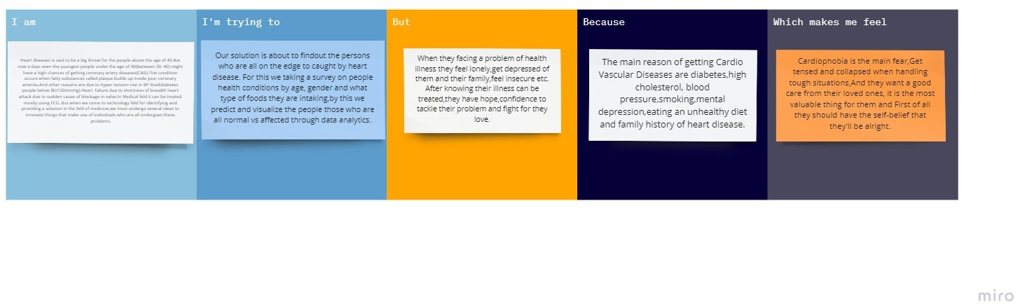

|  |  |  |  |  |  |
| --- | --- | --- | --- | --- | --- |
| **Problem Statemen t (PS)** | **I am (Customer)** | **I’m trying to** | **But** | **Because** | **Which makes me feel** |
| PS-1 | Heart diseases is said to be a big threat for the people above the age of 40.But now a days even the youngest people under the age of  40(between 30- 40) might have a high | Our solution is about to findout the persons who are all on the edge to caught by heart disease. | When they facing a problem of health illness they feel lonely,get depressed of them and their family,feel insecure etc. | The main reason of getting Cardio Vascular Diseases are diabetes,high cholesterol, blood pressure,smoking,menta l depression,eating an unhealthy diet and family history of heart disease. | Cardiophobia is the main fear,Get tensed and collapsed when handling  tough situations,An |
|  | chances of getting | d they want a |
|  | coronary artery | good care |
|  | diseases(CAD).Thi  s condition occurs when fatty | from their loved ones. |
|  | substances called |  |
|  | plaque builds up |  |
|  | inside your |  |
|  | coronary |  |
|  | arteries.And other |  |
|  | reasons are due to |  |
|  | hyper tension rise |  |
|  | in BP |  |
|  | level(diabetes |  |

|  |  |  |  |  |  |
| --- | --- | --- | --- | --- | --- |
|  | people below 80/120mmHg). |  |  |  |  |
| PS-2 | Heart faliure due  to shortness of | For this we taking a survey on people health conditions by age, gender and what type of foods they are intaking,b y this we predict and visualize the people those who are all normal vs affected through  data analytics. | After knowing their illness can be treated,they have hope,confidenc e to tackle their problem and fight for they love. | The main reason of getting Cardio Vascular Diseases are diabetes,high cholesterol, blood pressure,smoking,menta l depression,eating an unhealthy diet and family history of heart disease. | It is the most valuable thing for them  and First of all they should have the self-belief that they'll be alright. |
|  | breadth heart |
|  | attack due to |
|  | sudden cause of |
|  | blockage in |
|  | valve.In Medical |
|  | feld it can be |
|  | treated mostly |
|  | using ECG. But |
|  | when we come to |
|  | technology feld for |
|  | identifying and |
|  | providing a |
|  | solution in the feld |
|  | of medicine,we |
|  | must undergo |
|  | several ideas to |
|  | innovate things |
|  | that make use of |
|  | individuals who |
|  | are all undergoes |
|  | these problems |